ASSIGNMENT – 6

Using special operators in conditions.
Q1) write two different queries that would produce all orders taken on October 3rd or 4th, 1990.
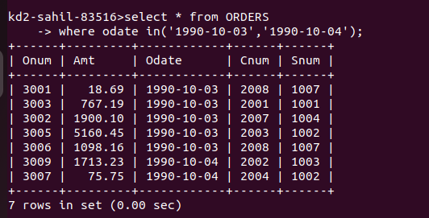

Q2) write a query that selects all the customers serviced by Peel or Motika.
(Hint : the snum fieldm relates the two tables to one another).
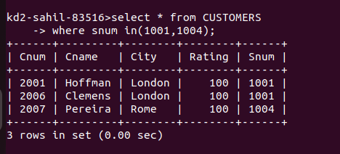

Q3) write a query that will produce all the customers whose names begins with a letter from ‘A’ to ‘G’ .
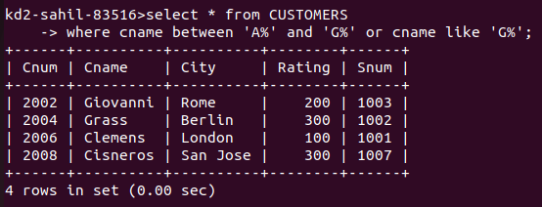

Q4) write a query that selects all customers whose names begins with the letter ‘C’ .

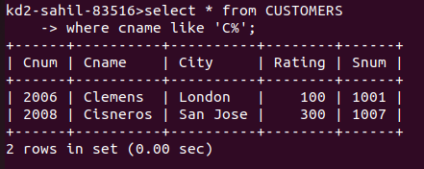

Q5) write a query that selects all orders except those with zeros or NULLs in the amt field.
